WRITING A PAPER FOR THE INTERNATIONAL CONFERENCE ON MULTIDISCIPLINARY DESIGN OPTIMIZATION OF AEROSPACE SYSTEMS

First A. Author¹*, Second B. Author² and Third C. Author²
1: Group or Department of First A. Author
School or Faculty
University
Postal address
FirstAuthor@university123.edu, http://www.university123.edu

2: Group/Department of Second B. Author and Third C. Author
School or Faculty
University
Postal address
{SecondAuthor, ThirdAuthor}@company456.com http://www.company456.com

Abstract This document provides all the information and instructions you need to write your paper for inclusion in the Proceedings of the AeroBest 2023 2nd International Conference on Multidisciplinary Design Optimization of Aerospace Systems, which is taking place in Lisbon, Portugal, from the 19th to 21st of July 2023. Papers must be written in English, using LaTeX or Word. The first page must contain: the title of the paper, authors names and institutions, keywords and abstract. This page will be used for the book of abstracts and must not exceed one page. The instructions, plus sample files for LaTeX and Word can be found in the Authors Area in the conference website http://aerobest2023.idmec.tecnico.ulisboa.pt/.
Keywords: Instructions, international conference, multidisciplinary, design, optimization, aerospace

1. INTRODUCTION
Abstracts proposals should not exceed 1500 words, and cannot have tables or figures. Their submission is made via the Easychair website, until February 28th, 2023, as detailed in http://aerobest2023.idmec.tecnico.ulisboa.pt/.
The Proceedings, including full text, tables and figures, will be published electronically in Portable Document Format (pdf). Accepted papers must also be submitted via the Easychair website, before May 31st, 2023. Papers must follow the LaTeX or Word format shown in the samples on the “Instructions for authors” page. Papers must be converted into Portable Document Format (pdf) prior to sending. The organisers cannot commit to including any paper in the Proceedings that is received after the stipulated deadline. At least one author must be registered and have paid the requisite fee by May 31st, 2023 for the paper to be included in the conference programme. A book of abstracts containing the basic information about each paper will be published in addition to the Proceedings.

2. GENERAL SPECIFICATIONS
The paper must be written in English using standard A4 page size, corresponding to a width of 210 mm and a height of 297 mm. The print area must be centred on each page and should cover an area of 160 mm x 237 mm, giving top and bottom margins of 30 mm and left and right margins of 25 mm.
The paper and its figures, tables and references must be at least 4 pages and no more than 20 pages long. The file may not exceed 10 MB.

3. FIRST PAGE
The first page must contain the title, author(s) and relevant institution(s), abstract and keywords. The introduction must start on the second page and follow the format of this file.

3.1. Paper title
The title must be in Times New Roman, 14 pt font, bold, upper case and centred. If the title occupies more than one line, the line spacing should be single.

3.2. Authors
Authors’ names must be given in full (not initials), i.e., given names and surname (see beginning of this document). The names must be in Times New Roman, 12 pt font, bold, and 12 pt below the title. If the Word template is used, a header with the authors’ names must be included.

3.3. Institution
Details of the authors’ institution(s) must be in Times New Roman, 11 (10.95) pt, 12 pt below the list of authors. The line spacing between the institutions should be 12 pt.

3.4. Abstract (in the body of the paper)
The body of the paper must contain an abstract thereof, written in Times New Roman, 12 pt, italics. The word Abstract must be in bold and not in italics at the start of the first line. The Abstract text must be justified, in italics and have a 12 pt space between it and the institutions, as shown on the first page of these instructions.
The abstract must not, in any circumstances, extend beyond the space available on the first page. This first page, with the paper’s title, its authors names and institutions, abstract and keywords, will be used for the book of abstracts.

3.5. Keywords
No more than six keywords are allowed. They should be aligned left and in Times New Roman 12 pt. The first line must start with the word Keywords, in bold. The line spacing between the abstract and keywords should be 12 pt.

4. SECTIONING

4.1. Sections
The sections (main headings) must be aligned left, Times New Roman 12 pt font, bold, upper case. Line spacing must be 12 pt before and 6 pt after each main heading.

4.2. Subsections
The subsections (subheadings) must be aligned left, Times New Roman 12 pt font, bold, initial capital for first word. Line spacing must be 12 pt before and 6 pt after each subheading.

5. HEADERS
As shown in these instructions, the first page has one header and the header of the remaining pages consists of the authors’ names, which should follow the format included in these instructions. Note that the headers are outside the print area.

6. Text
The main body text shall be Times New Roman, 12 pt, single spaced, justified and in a single column. No extra spacing is required between paragraphs.
7. PAGE NUMBERING
Papers will be indexed by author, title or topic. Page numbering is therefore not allowed.

8. FIGURES
All figures should be numbered consecutively and identified by their caption placed beneath it. Figure captions must be Times New Roman, 10 pt using both upper and lower case, and centred. There must be a 6 pt space between each figure and its caption, and a 12 pt space between the body text and the upper border of the figure and the last line of the caption and the next section of the text.
All figures must be referenced in the text. Figure 1 shows an example. If the reference occurs in the middle of a sentence, abbreviate to Fig.1. If appropriate, side-by-side pictures with sub-captions are recommended, as shown in Fig.2.

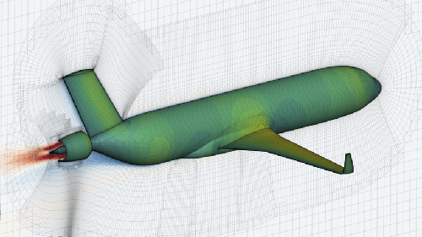
Figure 1. Example of figure.
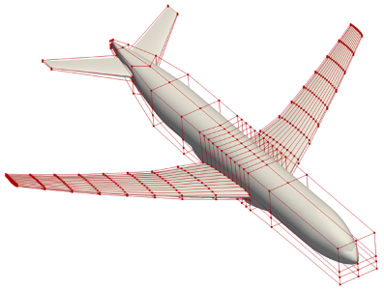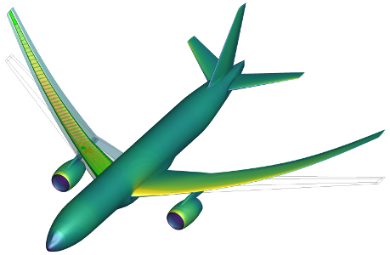
- A subfigure (b) Another subfigure
Figure 2. A figure.
9. TABLES
All tables should be numbered consecutively and identified by their caption placed above it. Table captions must be Times New Roman, 10 pt using both upper and lower case, and centred. There must be a 6 pt space between each table and its caption, and a 12 pt space between the body text and the caption, and the last line of the table and the next section of the text.
Table 1. Example of table.
Hdr 1 | Hdr 2 | Hdr 3
C11 | C12 | C13
C21 | C22 | C23
C31 | C32 | C33

10. EQUATIONS
Equations must be numbered in Arabic numerals, enclosed in brackets. Equations must be centred and separated from the text above and below by a 6 pt space.
Equations may or may not be referenced in the text. Equation (1) shows a single-line
example. If the reference occurs in the middle of a sentence, abbreviate to Eq.(1).

$A \text{Γ=v}$ (1)

The example below is a group of aligned equations:

$\begin{matrix}Minimize & Y\left(α,q\left(α\right)\right) \\ w.r.t. & α \\ subject to & R\left(α,q\left(α\right)\right)=0 \\ & C\left(α,q\left(α\right)\right)=0\end{matrix}$ (2)

11. REFERENCES
References within the text must be cited using numbers enclosed by square brackets [1]. At the end of the text, references must be included in numerical order, as shown at the end of these instructions. If multiple references are cited at once, compress them as [2-5].

12. CONCLUSIONS
The paper must have a section containing some final considerations and the main conclusions drawn from the work described that will be presented at the conference.
- Abstracts proposals and papers should be submitted electronically via the conference Easychar website, as detailed in http://aerobest2023.idmec.tecnico.ulisboa.pt/;
- Papers must be written in accordance with the format of the files available on the Instructions for Authors section;
- Papers must be converted into Portable Document Format (pdf) prior to submission.
- Papers must be sent by May 31st, 2023;
- The organisers cannot undertake to include papers received after that date;
- At least one author must be registered and have paid the requisite fee by May 31st, 2023 for the paper to be included in the conference programme.

acknowledgments
Acknowledge persons and institutions that supported the work.

references
  - A. C. Marta. Aircraft optimal design.
https://fenix.tecnico.ulisboa.pt/homepage/ist31052/concepcao-optimizada-de-aeronaves-meaer, September 2022. MSc course notes, Intituto Superior Técnico, Universidade de Lisboa.
  - A. C. Marta. Multidisciplinary design optimization of aircraft.
https://fenix.tecnico.ulisboa.pt/homepage/ist31052/optimizacao-multidisciplinar-de-aeronaves, September 2022. PhD course notes, Intituto Superior Técnico, Universidade de Lisboa.
  - D. P. Raymer. Aircraft Design: A Conceptual Approach. AIAA Education Series, 5th edition, 2012. ISBN 9781600869112.
  - J. R. R. A. Martins and A. B. Lambe. Multidisciplinary design optimization: A survey of architectures. AIAA Journal, 51(9):2049-2075, 2013. doi:10.2514/1.J051895.
  - J. R. R. A. Martins and A. Ning. Engineering Design Optimization. Cambridge University Press, 2021. ISBN 9781108980647.

